To generate a client package for an Ewon Cosy+ or Flexy, click the ‘Deploy as Cosy+/Flexy’ button under the Action section.
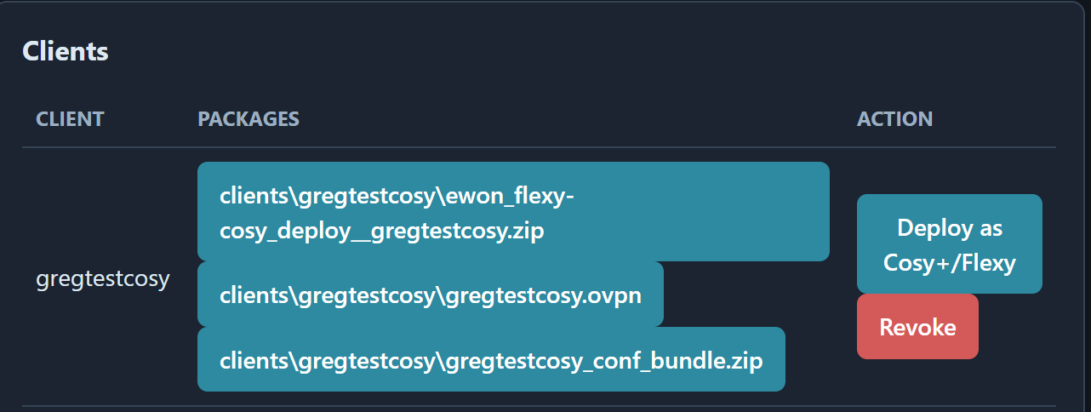
Open Zip file and Extract
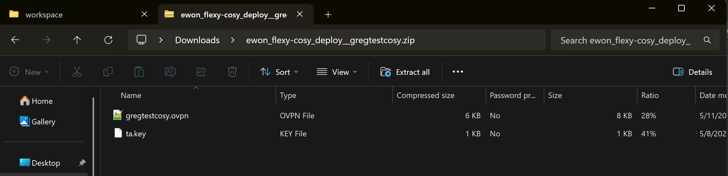
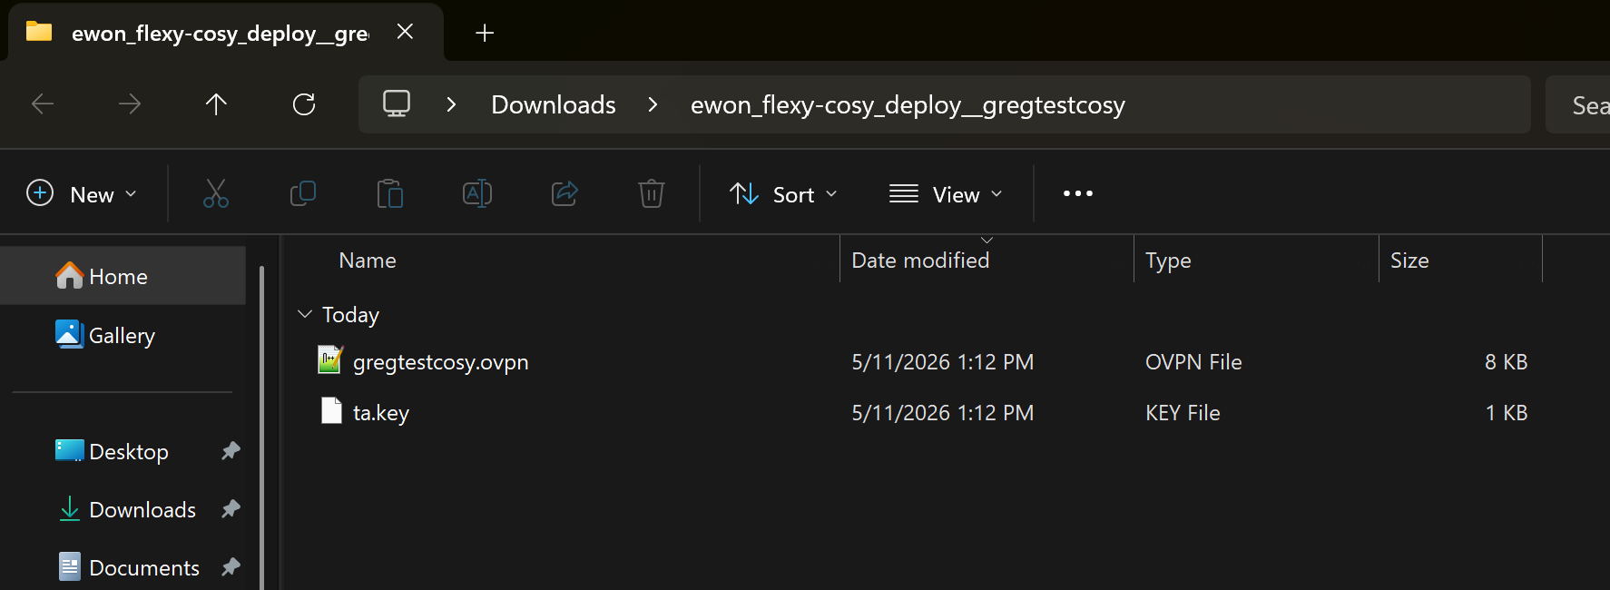
Log in to the Web GUI of the Ewon Cosy+/Flexy
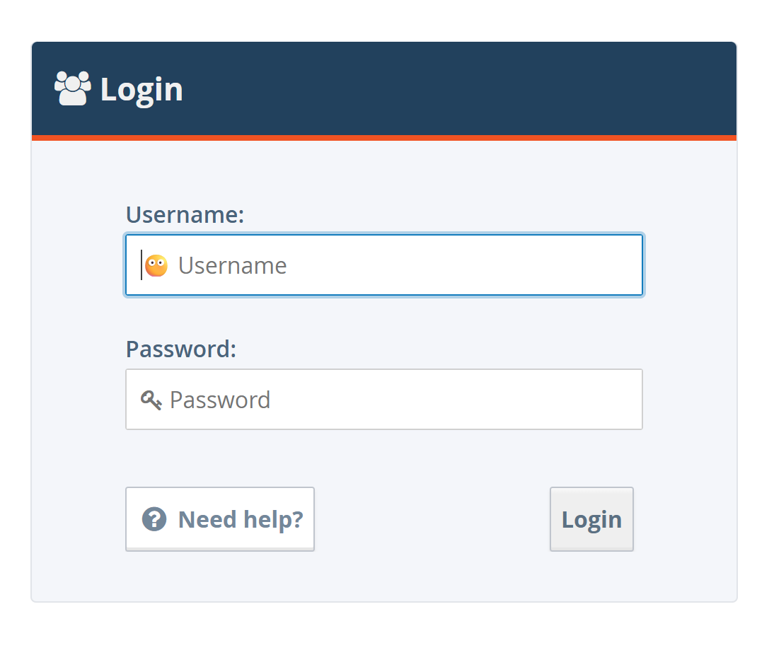
Navigate to Setup>System>Storage>Tabular Edition> Edit Com Cfg
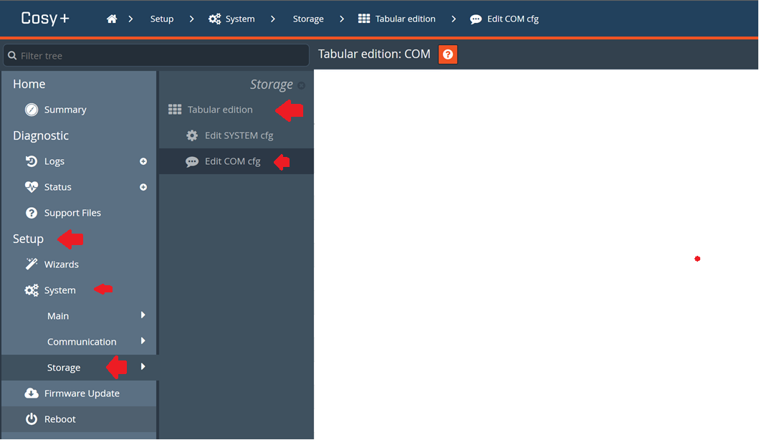
Use the COM Cfg Filter search to locate and modify the following COM configuration parameters: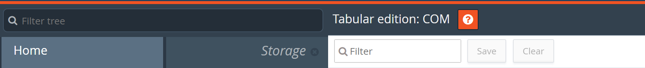
ClosedDevice change from 21 to 0 – This will open port 21 to allow FTP communication
VPNCnxType change from 0 to 2 – This will set the VPN Connection Type to VPN Client
VPNCfgFile change from blank to client config file name ex. /usr/gregtestcosy.ovpn
Once these changes have been made, click the save button next to Filter search bar
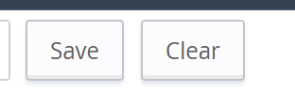

Using an FTP client such as WinSCP, connect to the device and upload the .ovpn and ta.key files to the /usr/
directory
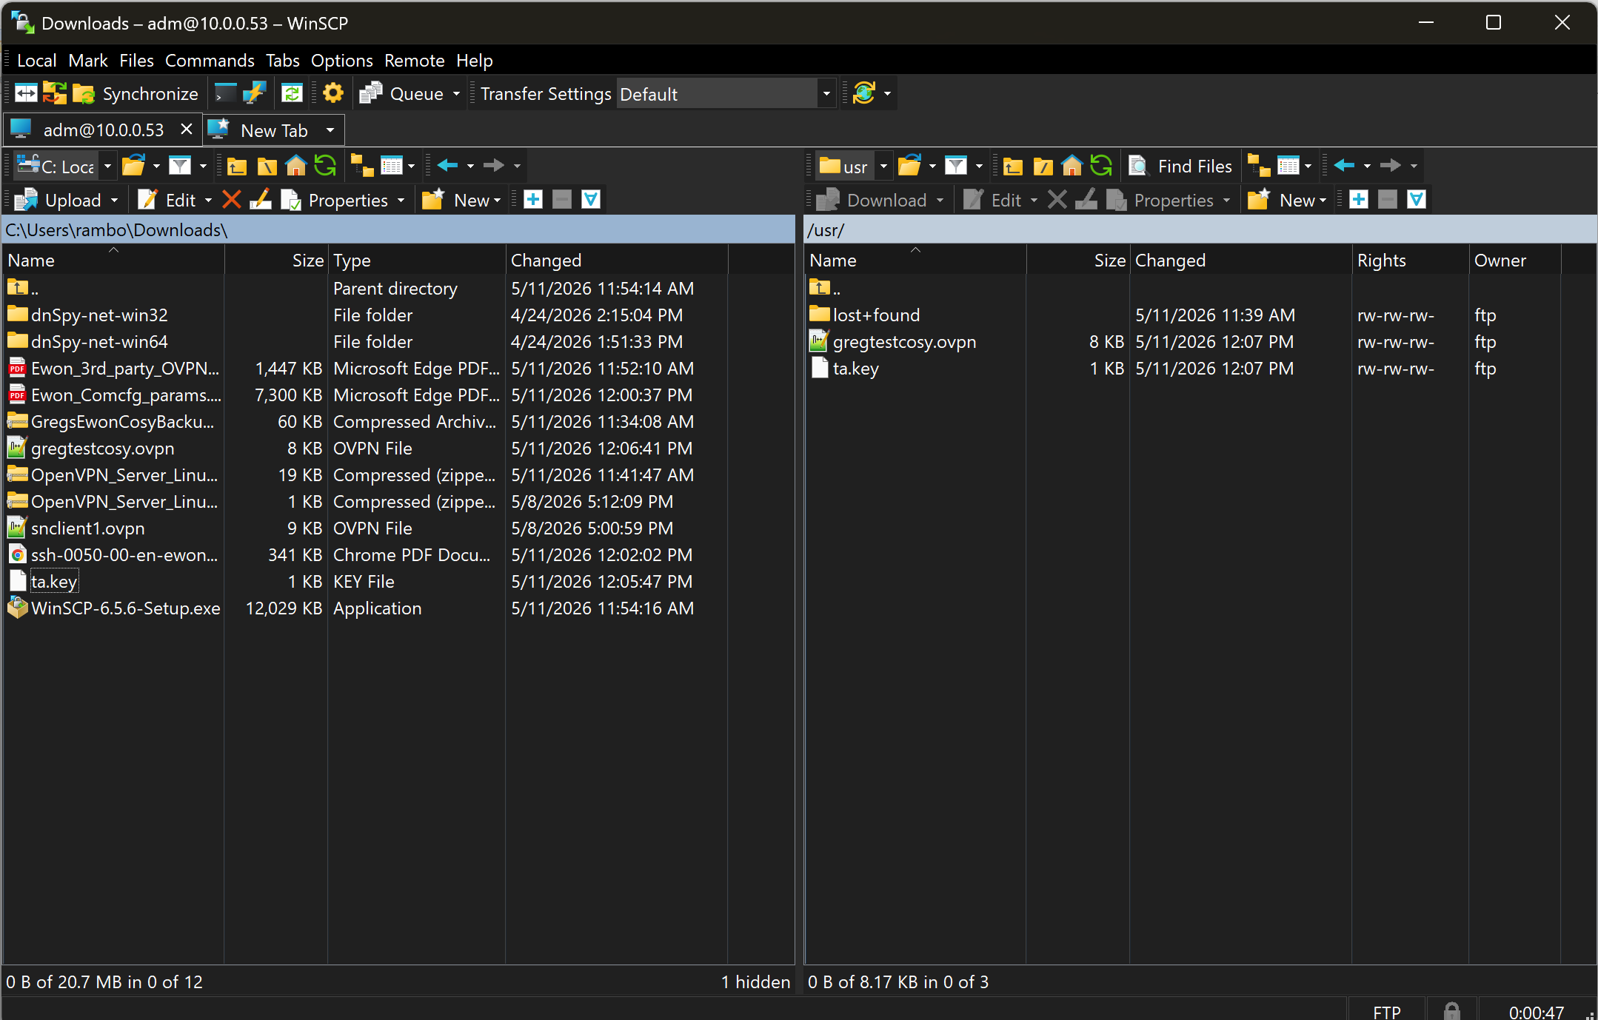
Once the configuration is complete, the VPN connection status should indicate a successful connection to the OpenVPN server
